Project - High Level Design

Deployment of Hospitality-Application to Kubernetes
  - Course Name: DevOps

Institution Name: Medicaps University – Datagami Skill Based Course

Sr no | Student Name | Enrolment Number
1 | HARSH RAI | EN22CS301393
2 | HEMANT DHAKAD | EN22CS301421
3 | GAURAV DWIVEDI | EN23CS3L1008
4 | HIMANI JAISWAL | EN22CS30123
5 | HARSHWARDHAN YADAV | EN22CS301416
6 | GOUTAM VERMA | EN22CS301375

Group Name: 12D4
Project Number: AAI- 08
Industry Mentor Name:
University Mentor Name: Avnesh Joshi
Academic Year: 2025 - 2026

Table of Contents

- Introduction.
  - Scope of the document.
  - Intended Audience
  - System overview.
- System Design.
  - Application Design
  - Process Flow.
  - Information Flow.
  - Components Design
  - Key Design Considerations
  - API Catalogue.
- Data Design.
  - Data Model
  - Data Access Mechanism
  - Data Retention Policies
  - Data Migration
- Interfaces
- State and Session Management
- Caching
- Non-Functional Requirements
  - Security Aspects
  - Performance Aspects
- References

1. Introduction
The Hospitality Application DevOps Pipeline is designed to automate the build, packaging, and deployment of a containerized web application using modern DevOps practices. The system leverages a combination of continuous integration and continuous deployment (CI/CD) tools to ensure efficient, reliable, and repeatable software delivery.
The pipeline integrates source control, containerization, orchestration, and automation technologies, including GitHub, Jenkins, Docker, Docker Hub, and Kubernetes. This integration enables seamless transformation of application source code into a fully deployed and accessible service running on a Kubernetes cluster.
The system is built around a containerized Python Flask application and demonstrates key DevOps principles such as infrastructure as code, automated pipelines, and zero-downtime deployments. Kubernetes is used as the orchestration platform to manage container lifecycle, scaling, and service exposure, while Docker ensures consistency across development and production environments.
The pipeline follows a structured workflow where code changes pushed to the repository trigger automated build and deployment processes. Docker images are created and versioned, stored in a centralized registry, and deployed to the Kubernetes cluster using rolling update strategies to maintain high availability.
The system enables developers to rapidly deliver updates while ensuring system stability, scalability, and minimal service disruption. By incorporating automation and orchestration, the DevOps pipeline provides a robust foundation for modern application deployment and continuous delivery.

  - Scope of the Document
This document provides the High-Level Design (HLD) of the Hospitality Application DevOps Pipeline. It includes:
- Overall system architecture and deployment design
- CI/CD pipeline design and workflow automation
- Containerization strategy using Docker
- Kubernetes deployment and orchestration design
- Deployment pipeline flow and process automation

- Integration with tools such as GitHub, Jenkins, and Docker Hub
- Infrastructure setup for local (Minikube) and cloud (AWS) environments
- Security, scalability, performance, and other non-functional requirements
This document serves as a technical reference for implementation, evaluation, and future enhancement of the DevOps pipeline system

1.2 Intended Audience
This document is intended for the following stakeholders:
- DevOps Engineers – to understand the CI/CD pipeline design, deployment workflow, and automation processes
- Software Developers – to understand how code changes are built, packaged, and deployed into the Kubernetes environment
- System Architects – to review the overall system architecture, containerization strategy, and orchestration design
- Cloud Engineers – to understand the deployment setup on local (Minikube) and cloud environments (AWS)
- Academic Evaluators and University Mentors – to assess the design, implementation approach, and adherence to DevOps best practices
- Project Maintainers – to use this document as a reference for future enhancements, scaling, and maintenance of the system

  - System Overview
The Hospitality Application DevOps Pipeline manages the automated build, packaging, and deployment of a containerized web application using a structured CI/CD workflow. The system integrates multiple DevOps tools to ensure continuous integration, continuous delivery, and reliable application deployment on a Kubernetes cluster.
The system workflow includes:
- The developer writes code and pushes changes to the GitHub repository.
- The CI/CD pipeline is triggered automatically through Jenkins upon code commit.
- Jenkins checks out the latest source code and builds a Docker image of the application.
- The Docker image is tagged with a version and pushed to Docker Hub as a centralized image repository.
- Jenkins updates the Kubernetes deployment configuration with the new image version.
- The updated configuration is applied to the Kubernetes cluster using kubectl commands.
- Kubernetes performs a rolling update by gradually replacing old pods with new ones while ensuring application availability.
- The application is exposed externally through a NodePort service, allowing users to access it via a web browser.

The system is modular and automation-driven, demonstrating key DevOps principles such as continuous integration, continuous deployment, infrastructure as code, and zero-downtime deployments
2. System Design
The system follows a layered DevOps architecture that enables automation, scalability, and efficient application deployment. Each layer is designed to handle a specific responsibility within the CI/CD and deployment lifecycle.
Layers include:
- Source Control Layer (GitHub Repository)
Stores application source code, Dockerfile, and Kubernetes manifests. Acts as the entry point for triggering the CI/CD pipeline.
- CI/CD Layer (Jenkins Pipeline)
Automates the build, test, and deployment process. Responsible for pulling code, building Docker images, pushing them to the registry, and deploying updates to Kubernetes.
- Containerization Layer (Docker)
Packages the application along with its dependencies into a portable container, ensuring consistency across development, testing, and production environments.

- Registry Layer (Docker Hub)
Stores versioned Docker images and acts as a centralized repository from which Kubernetes pulls images during deployment.
- Orchestration Layer (Kubernetes)
Manages container deployment, scaling, and lifecycle. Handles rolling updates, self-healing, and load distribution across multiple replicas.
- Service Exposure Layer (Kubernetes Service – NodePort)
Exposes the deployed application to external users by routing traffic from a node port to the running pods.
The design ensures high availability, modularity, and seamless integration between components, enabling reliable and automated application delivery.

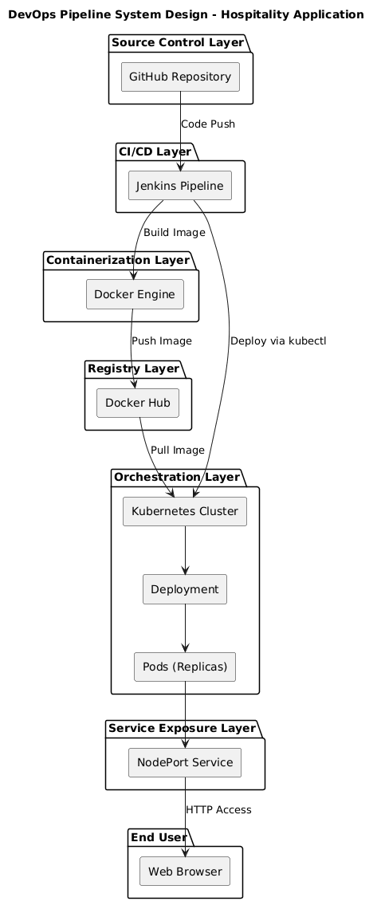

2.1 Application Design
he Hospitality Application is a lightweight web application built using Python Flask and designed to be deployed in a containerized and orchestrated environment. The application follows a simple and modular design to ensure ease of deployment, scalability, and integration with DevOps pipelines.
Frontend (Application Interface)
- The application exposes a single HTTP endpoint ("/") that returns a basic response message.
- Accessible through a web browser via the Kubernetes NodePort service.
- Designed to be minimal, as the focus of the project is on deployment and DevOps practices rather than UI complexity.

Backend (Flask Application)
- Developed using the Flask framework in Python.
- Handles incoming HTTP requests and returns responses.
- Runs on host 0.0.0.0 and port 5000 to allow external access within containers.
- Stateless design, with no database dependency, ensuring simplicity and easy scalability.

Application Server
- Uses Gunicorn as the production-grade WSGI server.
- Handles multiple requests efficiently compared to the Flask development server.
- Configured to bind to port 5000 inside the container.

Containerized Environment
- The application is packaged into a Docker container along with all required dependencies.
- Ensures consistent runtime behavior across development, testing, and production environments.
- Lightweight base image is used to optimize performance and reduce image size.

Integration with Kubernetes
- The containerized application is deployed as a Kubernetes Deployment with multiple replicas.
- Kubernetes manages:
  - Pod lifecycle
  - Scaling
  - Self-healing (automatic restarts)
- The application is exposed using a NodePort Service, allowing external access.

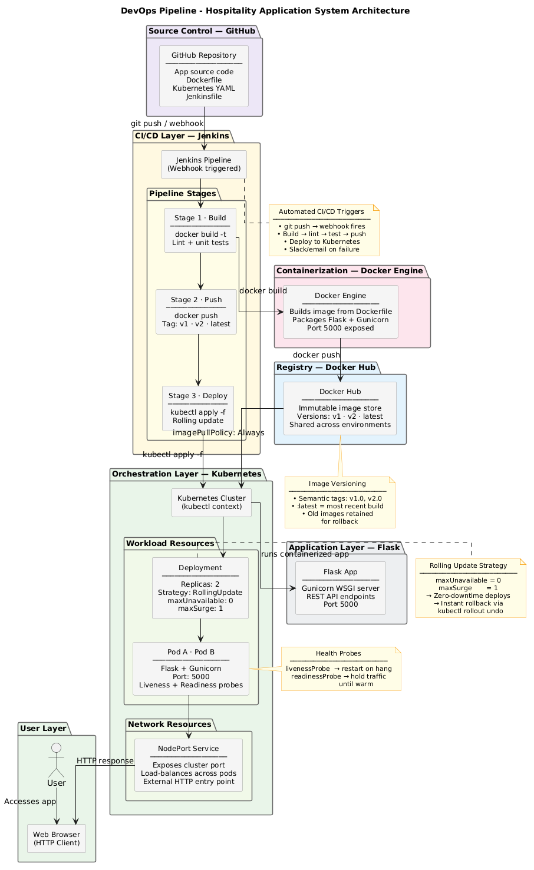

2.2 Process Flow
The Hospitality Application DevOps Pipeline follows a structured and automated process flow to ensure continuous integration and continuous deployment of the application. The complete end-to-end workflow is as follows:
- Code Development and Commit
The developer writes or updates the application code and pushes changes to the GitHub repository.
- Pipeline Trigger
The Jenkins pipeline is automatically triggered upon a code push event in the repository.
- Source Code Checkout
Jenkins pulls the latest code from the GitHub repository for processing.
- Docker Image Build
Jenkins uses the Dockerfile to build a new Docker image of the application, packaging all dependencies.
- Image Tagging and Versioning
The Docker image is tagged with a version identifier (e.g., v1, v2, or commit SHA) for traceability.
- Push to Docker Hub
The built Docker image is pushed to Docker Hub, making it available for deployment.
- Update Deployment Configuration
The Kubernetes deployment configuration is updated with the new image tag.
- Deployment to Kubernetes
Jenkins applies the updated configuration to the Kubernetes cluster using kubectl commands.
- Rolling Update Execution
Kubernetes performs a rolling update by creating new pods with the updated image and gradually terminating old pods, ensuring zero downtime.
- Service Exposure
The NodePort service routes external traffic to the running pods within the cluster.

- Application Access
End users access the deployed application through a web browser using the exposed service endpoint.
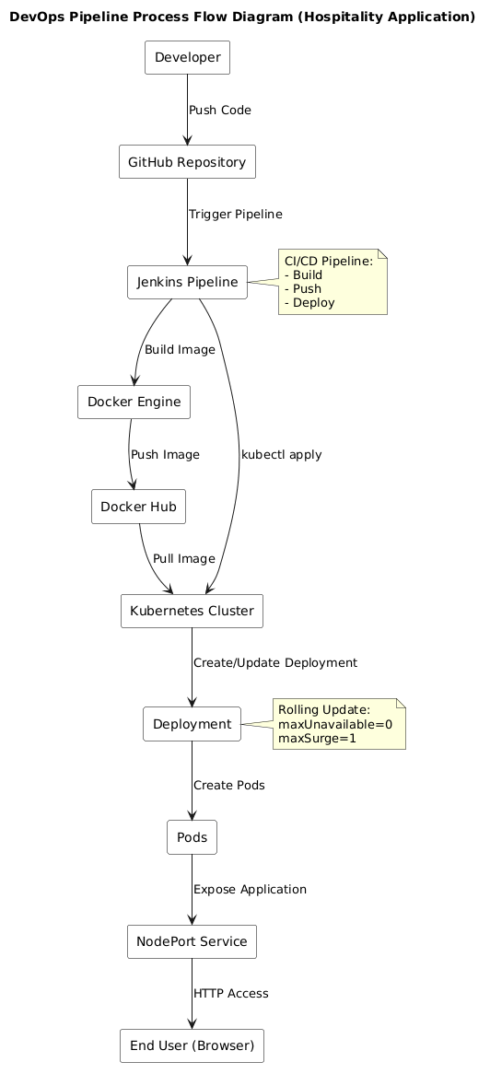

2.3 Information Flow
- The developer pushes source code to the GitHub repository.
- A webhook event triggers the Jenkins pipeline.
- Jenkins retrieves the latest code and builds a Docker image.
- The image is pushed to Docker Hub with a version tag.
- Jenkins updates the Kubernetes deployment configuration with the new image reference.
- Kubernetes pulls the updated image and deploys new pods.
- The NodePort service routes external requests to the running pods.
- The application processes requests and sends responses back to the user’s browser

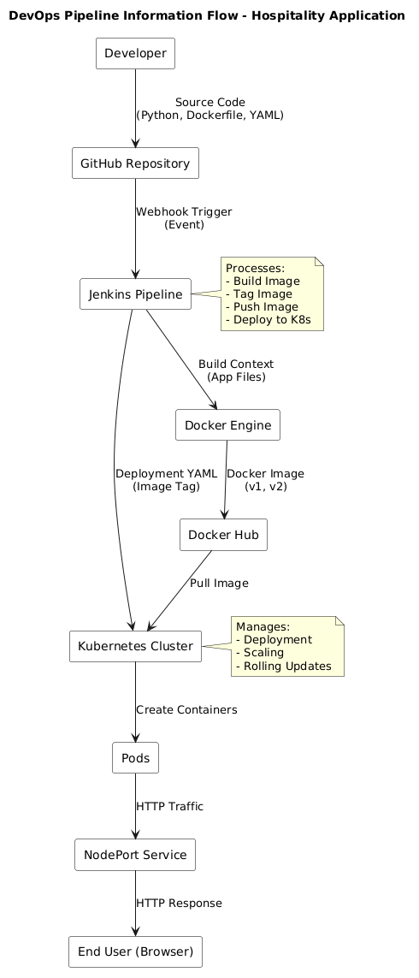

2.4 Component Design
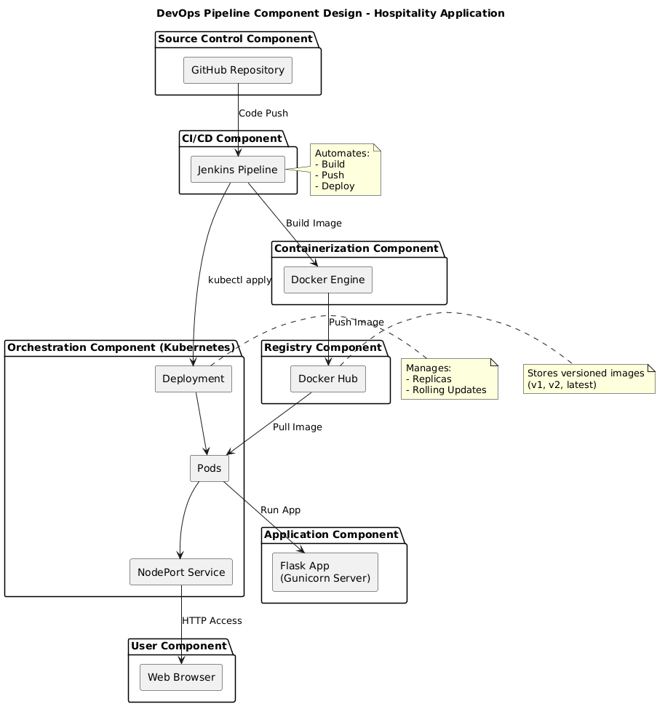

2.5 Key Design Considerations
- Automation-First Approach: The system is designed with a strong emphasis on automation, where the entire build, test, and deployment process is handled through a CI/CD pipeline, reducing manual intervention and human error.
- Containerization Strategy: The application is packaged using Docker to ensure consistency across development, testing, and production environments, eliminating environment-related issues.
- Modular Architecture: Each component (GitHub, Jenkins, Docker, Kubernetes) operates independently, allowing easy replacement, scaling, or enhancement without impacting the overall system.
- Zero Downtime Deployment: Kubernetes rolling update strategy (maxUnavailable=0, maxSurge=1) ensures that application updates occur without service interruption.
- Scalability and High Availability: The use of Kubernetes deployments with multiple replicas ensures that the system can handle increased load and remains available even in case of failures.
- Secure Credential Management: Sensitive information such as Docker Hub credentials and Kubernetes access configurations are managed securely within Jenkins using credential management systems, avoiding exposure in source code.
- Version Control and Traceability: Docker images are tagged with versions (v1, v2, or commit SHA), enabling easy tracking, rollback, and reproducibility of deployments.
- Infrastructure as Code (IaC): Kubernetes manifests (deployment.yaml, service.yaml) are maintained as code, ensuring consistency, versioning, and repeatability of infrastructure setup.
- Portability: The system is designed to run seamlessly on local environments (Minikube) as well as cloud platforms (AWS), ensuring flexibility in deployment.
- Future Extensibility: The architecture supports integration of advanced features such as automated testing, monitoring (Prometheus/Grafana), auto-scaling, and migration to managed Kubernetes services like AWS EKS without major redesign.

2.8 API Catalogue
The Hospitality Application DevOps Pipeline integrates multiple tools and services that communicate through APIs, CLI commands, and webhooks to enable automated build and deployment workflows.
API / Service | Provider | Purpose | Details
GitHub Webhook API | GitHub | Trigger CI/CD pipeline | Sends event-based triggers (push events) to Jenkins to start the pipeline
Jenkins REST API | Jenkins | Pipeline automation and management | Used to trigger jobs, monitor build status, and manage CI/CD workflows
Docker Engine API | Docker | Build and manage container images | Builds Docker images from source code and manages local containers
Docker Hub API | Docker | Image registry and storage | Stores versioned Docker images and allows push/pull operations
Kubernetes API Server | Kubernetes | Cluster management and deployment | Handles deployment, scaling, and management of containerized applications
kubectl CLI (API Client) | Kubernetes | Interact with Kubernetes cluster | Applies YAML configurations, updates deployments, and manages resources
Container Runtime Interface (CRI) | Kubernetes | Container execution | Enables Kubernetes to run containers using Docker or other runtimes
NodePort Service | Kubernetes | Application exposure | Exposes application to external users via a node port
AWS EC2 API (Optional) | AWS | Cloud infrastructure provisioning | Used to create and manage virtual machines for hosting Kubernetes cluster
Jenkins Credentials API | Jenkins | Secure credential management | Stores and manages sensitive data like Docker Hub credentials and access tokens

3. Data Design
The Hospitality Application DevOps Pipeline manages various types of data and artifacts throughout the build and deployment lifecycle. Unlike traditional applications, the system primarily handles code artifacts, container images, deployment configurations, and runtime states rather than business data.
3.1 Data Model

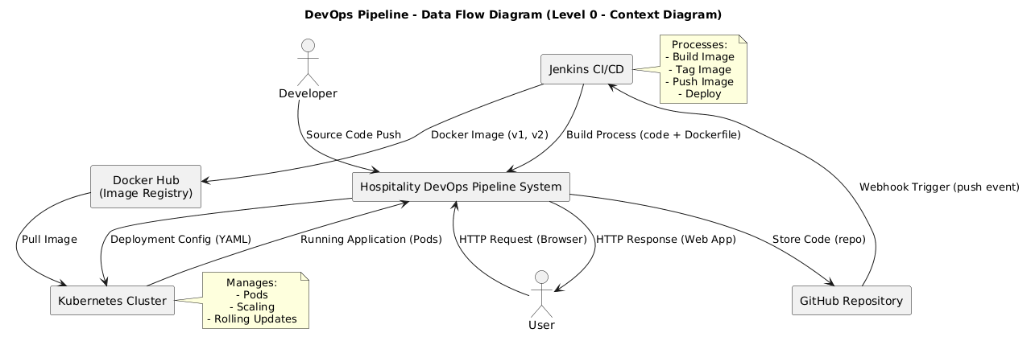

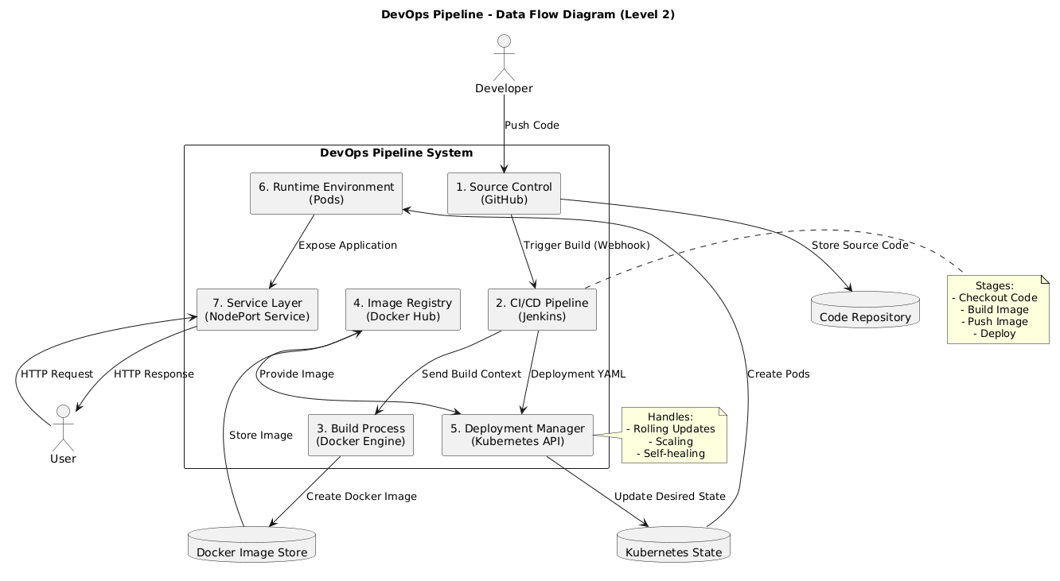

3.2 Data Access Mechanism
- Git-Based Access: Source code and configuration files are managed through GitHub using version control, enabling collaboration and tracking of changes.
- API-Based Communication: Jenkins, Docker, and Kubernetes interact using REST APIs and CLI tools (docker, kubectl) for automation of build and deployment processes.
- Container Registry Access: Docker Hub provides authenticated access to store and retrieve container images used during deployment.
- Kubernetes API Communication: kubectl communicates with the Kubernetes API server to manage deployments, pods, and services.
- HTTP Communication: End users interact with the deployed application via HTTP requests through the NodePort service.

3.3 Data Retention Policies
- Source Code Retention: Maintained in GitHub with complete version history for traceability and rollback.
- Docker Image Storage: Images are stored in Docker Hub with version tags (v1, v2, etc.); older images can be cleaned periodically.
- Pipeline Logs: Jenkins stores build and deployment logs for debugging, monitoring, and auditing purposes.
- Kubernetes State: The cluster maintains the current state of deployments and pods; outdated pods are automatically terminated during updates.
- Application Data: The application is stateless, and no persistent user data is stored.

3.4 Data Migration
Future scalability and flexibility options include:
- Cloud Migration: The system can be migrated from local Minikube to cloud environments such as AWS EC2 or EKS.
- Registry Migration: Docker images can be moved from Docker Hub to other registries like AWS ECR.

- Infrastructure Portability: Kubernetes manifests (YAML files) can be reused across environments without modification.
- Pipeline Migration: CI/CD pipeline can be extended or migrated to other tools such as GitHub Actions without affecting application logic.

4. Interfaces
4.1 User Interface
- Web-based access through a browser using the NodePort service
- Accessible via:
http://<node-ip>:<node-port>
- Provides a simple interface to verify application deployment
- Designed minimal, focusing on backend deployment rather than UI complexity

4.2 External System Interfaces
- GitHub API: Used to trigger CI/CD pipeline via webhook events on code push
- Docker Hub API: Used for pushing and pulling container images
- Kubernetes API: Used for managing deployments, pods, and services
- Jenkins API: Used for pipeline automation and job execution

4.3 Data Interface
- Docker Interface: Handles container image creation and management
- Kubernetes Interface: Manages deployment configurations and runtime state
- kubectl CLI Interface: Acts as the command-line client for interacting with Kubernetes API
- Service Interface: Routes external traffic to application pods

5. State and Session Management
- The application is stateless and does not maintain persistent user sessions.
- Kubernetes maintains the desired state of deployments and ensures consistency across pods.
- Pod lifecycle (creation, termination, restart) is managed automatically by Kubernetes.
- Rolling updates ensure state transition without affecting application availability.
- Future enhancement may include session persistence using external storage (e.g., Redis).

6. Caching
- Docker Layer Caching: Docker reuses cached layers during image builds to improve performance.
- Kubernetes Image Caching: Nodes cache pulled images to reduce repeated downloads.
- CI/CD Optimization: Jenkins can reuse previous build artifacts to reduce build time.
- Overall Benefit: Reduces deployment time, network usage, and improves system efficiency.

7. Non-Functional Requirements
The DevOps pipeline system satisfies the following requirements:
- Scalability: Kubernetes supports scaling through replicas and can be extended to auto-scaling.
- Reliability: Automatic container restart and self-healing ensure system stability.
- Maintainability: Modular design allows independent updates of pipeline components.
- Usability: Automated pipeline reduces manual effort and simplifies deployment.
- Security: Credentials are securely managed using Jenkins and environment variables.
- Performance: Lightweight containers and efficient orchestration ensure fast deployment and response times.

7.1 Security Aspects
- Credentials (Docker Hub, Kubernetes access) are securely stored in Jenkins credential manager
- Sensitive data is not stored in source code or repositories
- All communications (GitHub, Docker Hub, Kubernetes) occur over HTTPS
- Access to infrastructure is controlled via authentication and authorization mechanisms
- Secure handling of configuration files and environment variables

7.2 Performance Aspects
- Docker images are lightweight, reducing startup and deployment time
- Kubernetes efficiently manages resource allocation and load balancing
- Rolling updates minimize downtime and ensure continuous availability
- CI/CD pipeline automates repetitive tasks, reducing deployment latency
- Cached layers and images improve build and deployment speed

8. References
- Jenkins Documentation – https://www.jenkins.io/doc/
- Docker Documentation – https://docs.docker.com/
- Kubernetes Documentation – https://kubernetes.io/docs/
- GitHub Documentation – https://docs.github.com/
- AWS Documentation – https://docs.aws.amazon.com/

